Surafel Zelalem

ETR/8571/10 | Computer programming and application

Assignment Four

UI/UX explanation of my website

**UI/UX Design and explanation**

**UI (User Interface)**

This website is designed to have an interface that is simple to use and minimalistic. There 3 main colors of choice the background (White) the accent color (light gray) and the menu dropdown colors.

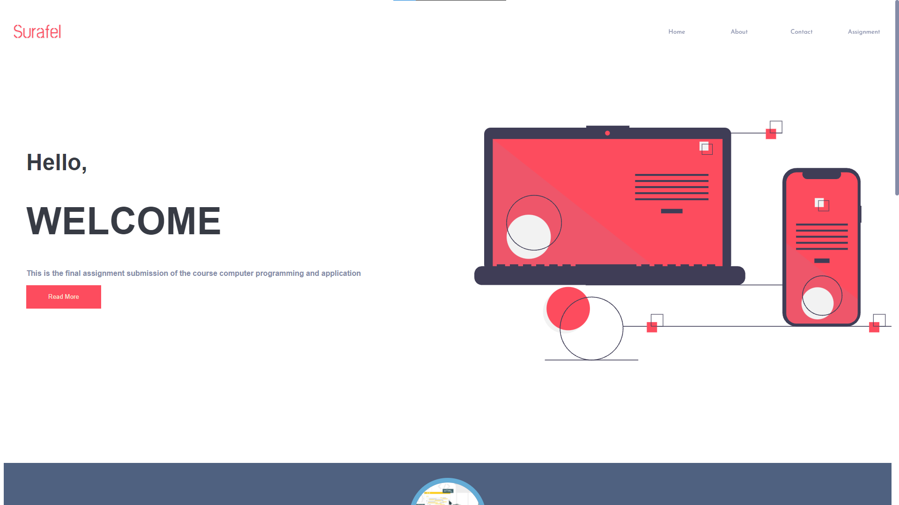

The navigation buttons are arranged in the right side of the screen for reachability and guidance to make it easy and familiar for the user to interact with the website like many other sites that are found on the internet.

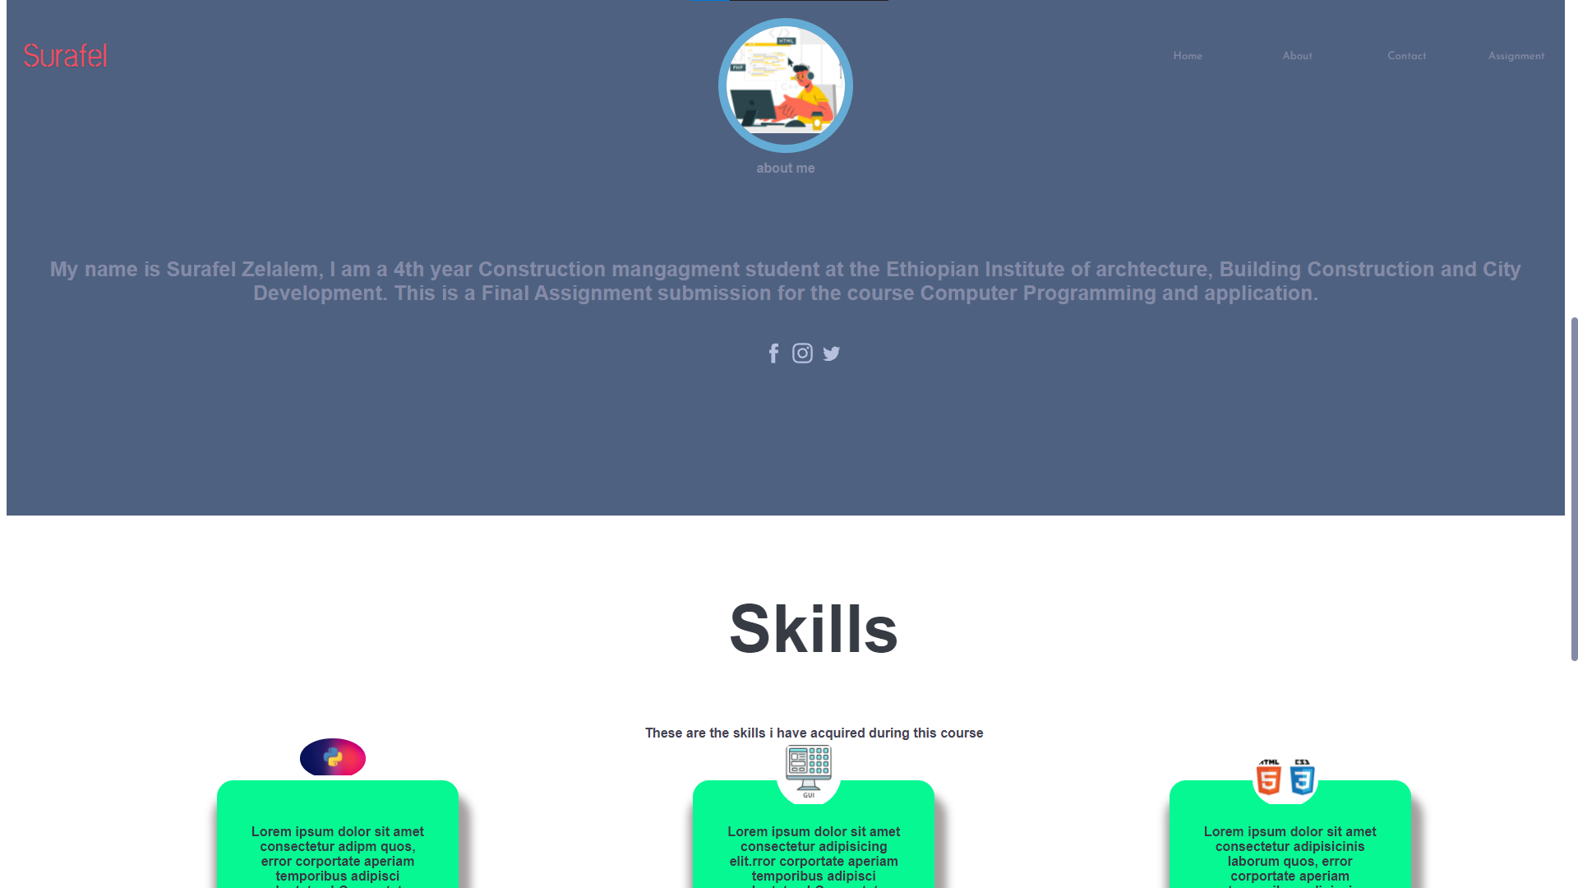

The contact page is also designed to give focus on the inputs and make it easy for the users to follow the steps to send feedback or messages to the developer.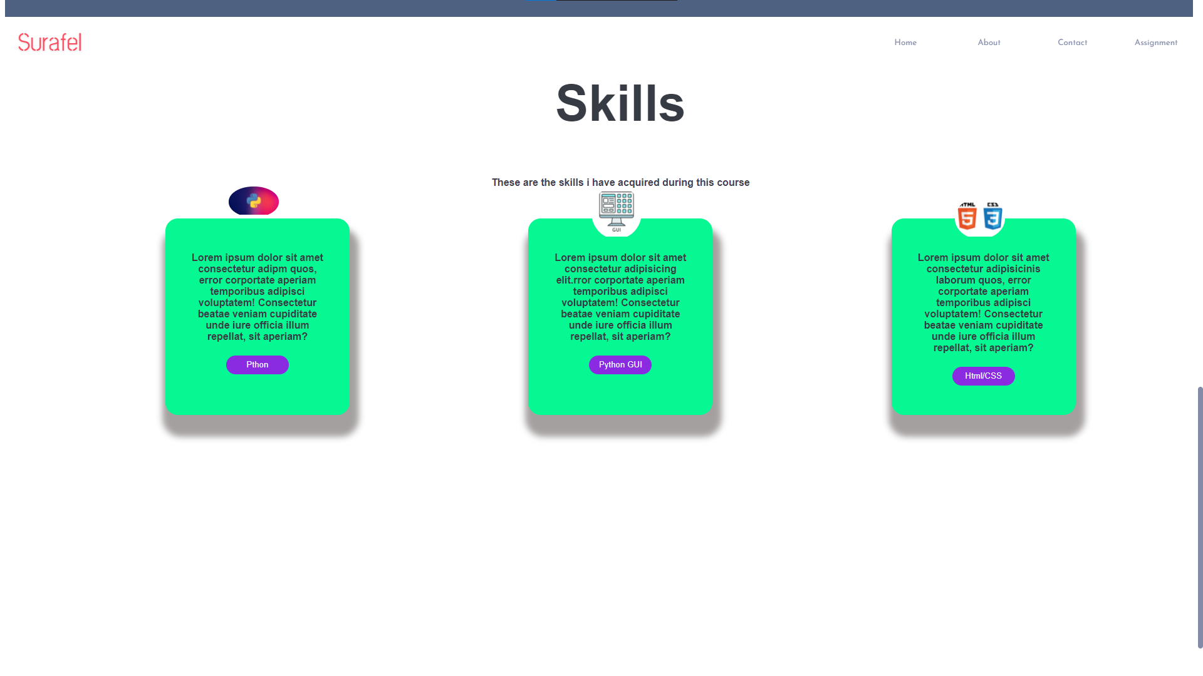

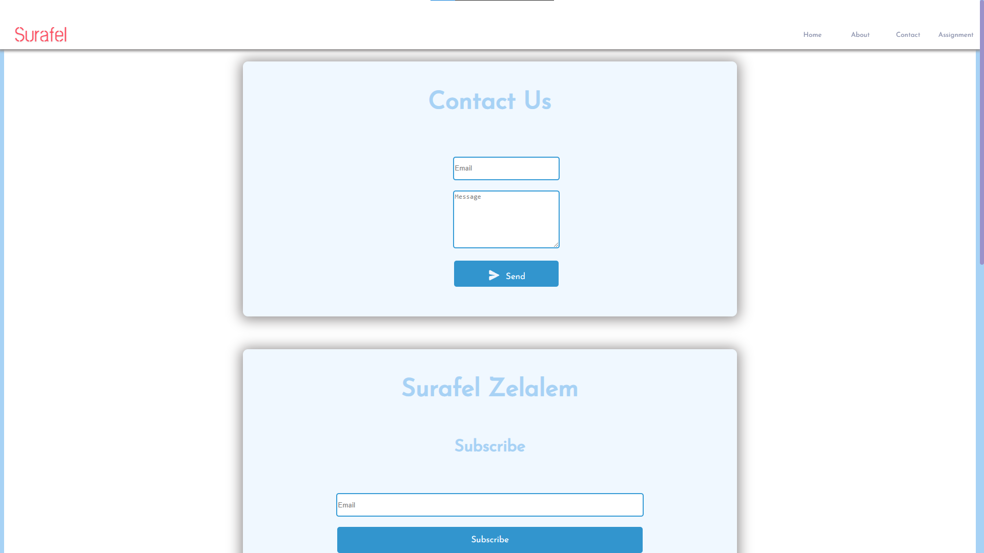

**UX (User Interface)**

The user experience of the website is focused around look and feel, Feedback, and Discoverability. Which means the user's experience should be pleasant in those fields and the website has to also be responsive with a very low lag time.

This website is also responsive to different size of screens including tablets, cellphones, and midsized laptops

I have also added svg buttons as social media icon that are clickable and will redirect to a social media page. The backgrounds I used are also SVG file code this optimizes the website file size and help to load it quick avoiding lags on slower connections.